 | 12.1.16 Editors - Geometry Nodes Editor - Header - Add Menu - Mesh Primitives
Table of content
Detailed table of content 1
Add menu - Mesh Primitives 4
Cone 4
Cube 5
Cylinder 5
Grid 6
Ico Sphere 7
Mesh Circle 7
Mesh Line 8
UV Sphere 9

Detailed table of content
Detailed table of content
Detailed table of content 1
Add menu - Mesh Primitives 4
Cone 4
Input 4
Vertices 4
Radius Top 4
Side Segments 4
Fill Segments 4
Radius Bottom 4
Depth 4
Properties 4
Fill Type 4
None 4
N-Gon 4
Triangles 5
Outputs 5
Geometry 5
Cube 5
Input 5
Size 5
Vertices 5
Output 5
Geometry 5
Cylinder 5
Input 5
Vertices 5
Side Segments 5
Fill Segments 5
Radius 6
Depth 6
Properties 6
Fill Type 6
None 6
N-Gon 6
Triangles 6
Outputs 6
Geometry 6
Grid 6
Input 6
Size 6
Vertices X 6
Vertices Y 6
Outputs 7
Geometry 7
Ico Sphere 7
Input 7
Radius 7
Subdivisions 7
Outputs 7
Geometry 7
Mesh Circle 7
Input 7
Vertices 7
Radius 7
Properties 7
Fill Type 7
None 8
N-Gon 8
Triangles 8
Outputs 8
Geometry 8
Mesh Line 8
Input 8
Count 8
Start Location 8
Offset 8
Properties 8
Mode 8
Offset 8
End Points 8
Count Mode 8
Count 8
End Points 9
Outputs 9
Geometry 9
UV Sphere 9
Input 9
Segments 9
Rings 9
Radius 9
Outputs 9
Geometry 9

Add menu - Mesh Primitives
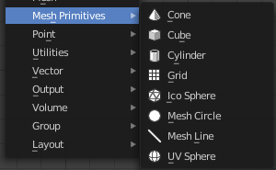
Nodes to modify the mesh geometry.

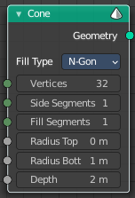
Cone
Cone creates a Cone mesh.

Input

Vertices
Number of vertices.

Radius Top
The initial radius at the top.

Side Segments
Adjust the number of segments at the side.

Fill Segments
Adjust the number of segments at the fill faces.

Radius Bottom
The initial radius at the bottom.

Depth
The initial height.

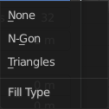
Properties

Fill Type
Defines how the Circle mesh is filled.

None
pure edge geometry.

N-Gon
The circle face is a N-Gon face.

Triangles
The circle face is triangulated.

Outputs

Geometry
Standard geometry output.

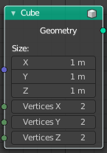
Cube
Cube creates a Cubeoid mesh.

Input

Size
The initial size in X , Y and Z dimensions

Vertices
How much vertices the single edges has. This allows to subdivide the cube.

Output

Geometry
Standard geometry output.

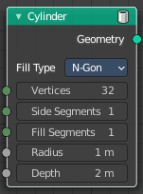
Cylinder
Cylinder creates a Cylinder mesh.

Input

Vertices
Number of vertices.

Side Segments
Adjust the number of segments at the side.

Fill Segments
Adjust the number of segments at the fill faces.

Radius
The initial radius.

Depth
The initial height.

Properties

Fill Type
Defines how the Circle mesh is filled.

None
pure edge geometry.

N-Gon
The circle face is a N-Gon face.

Triangles
The circle face is triangulated.

Outputs

Geometry
Standard geometry output.

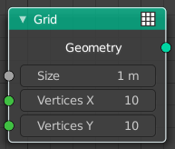
Grid
Grid creates a grid mesh.

Input

Size
The initial size.

Vertices X
The initial number of vertices in X direction.

Vertices Y
The initial number of vertices in Y direction.

Outputs

Geometry
Standard geometry output.

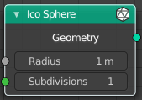
Ico Sphere
Ico Sphere creates a ico Sphere mesh.

Input

Radius
The initial radius.

Subdivisions
The initial subdivisions.

Outputs

Geometry
Standard geometry output.

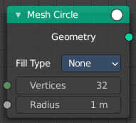
Mesh Circle
Circle creates a Circle mesh.

Input

Vertices
Number of vertices.

Radius
The initial radius.

Properties

Fill Type
Defines how the Circle mesh is filled.

None
pure edge geometry.

N-Gon
The circle face is a N-Gon face.

Triangles
The circle face is triangulated.

Outputs

Geometry
Standard geometry output.

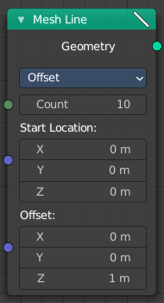
Mesh Line
Line creates a line mesh.

Input

Count
The initial number of segments.

Start Location
The initial location.

Offset
The initial offset.

Properties

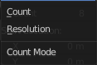
Mode

Offset
Specify the offset from one vertice to the next.

End Points
Specify the line start and endpoints.

Count Mode

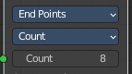
Count
Specify the number of total vertices.

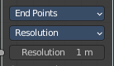
End Points
Specify the distance between the vertices.

Outputs

Geometry
Standard geometry output.

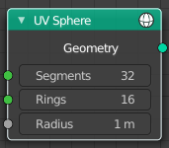
UV Sphere
UV Sphere creates a uv sphere mesh.

Input

Segments
The initial number of segments.

Rings
The initial number of edgerings.

Radius
The initial radius.

Outputs

Geometry
Standard geometry output.

